 **HEALTH CARE MANAGEMENT SYSTEM**

*MINI PROJECT-I REPORT submitted in partial fulfillment of the requirements*

*for the Award of the Degree of*

**BACHELOR OF TECHNOLOGY**

**In**

**INFORMATION TECHNOLOGY**

**By**

**ESA VINAY, 208W1A1212**

**GANDIKOTA PRASANTH SATYA SAI KIRAN, 208W1A1213**

**NANDIGAMA SUSHMA, 208W1A1235**

*Under the Guidance of*

**Dr.S.Suhasini,**

**Associate Professor**



**DEPARTMENT OF INFORMATION TECHNOLOGY**

**V R SIDDHARTHA ENGINEERING COLLEGE**

**(AUTONOMOUS - AFFILIATED TO JNTU-K, KAKINADA)**

**Approved by AICTE &Accredited by NBA**

**KANURU, VIJAYAWADA-520007**

**ACADEMIC YEAR**

**(2022-23)**

**V.R.SIDDHARTHA ENGINEERING COLLEGE**

(Affiliated to JNTUK: Kakinada, Approved by AICTE, Autonomous)

(An ISO certified and NBA accredited institution)

Kanuru, Vijayawada – 520007



**CERTIFICATE**

This is to certify that this project report titled “**HEALTH CARE MANAGEMENT SYSTEM”** is a bonafide record of work done by **ESA VINAY (208W1A1212), GANDIKOTA PRASANTH SATYA SAI KIRAN (208W1A1213) and NANDIGAMA SUSHMA (208W1A1235)** under my guidance and supervision is submitted in partial fulfillment of the requirements for the award of the degree of Bachelor of Technology in Information Technology, **V.R. Siddhartha Engineering College** (Autonomous under JNTUK) during the year 2022-23.

**(Dr.S.Suhasini)** (**Dr. M. Suneetha)**

Designation Professor &Head

Dept. of Information Technology Dept. of Information Technology

**EXTERNAL EXAMINER** **SIGNATURE**

*Date of examination:dd-mm-yy*

**ACKNOWLEDGEMENT**

First and foremost, I sincerely salute our esteemed institution **V.R SIDDHARTHA ENGINEERING COLLEGE** for giving me this opportunity for fulfilling my project. I am grateful to our principal **Dr. A.V.RATNA PRASAD**, for his encouragement and support all through the way of my project.

On the submission of this Project report, I would like to extend my honour to **Dr. M.Suneetha**, Head of the Department, IT for her constant motivation and support during the course of my work.

I feel glad to express my deep sense of gratefulness to my project guide **Dr.S.Suhasini** for **her** guidance and assistance in completing this project successfully.

I would also like to convey my sincere indebtedness to all faculty members, including supporting staff of the Department, friends and family members who bestowed their great effort and guidance at appropriate times without which it would have been very difficult on my part to finish the project work.

**DEPARTMENT OF INFORMATION TECHNOLOGY**

**V.R.SIDDHARTHA ENGINEERING COLLEGE**

**PROJECT SUMMARY**

|  |  |  |
| --- | --- | --- |
| S.No | Item | Description |
| 1 | **Project Title** | **HEALTH CARE MANAGEMENT SYSTEM** |
| 2 | **Student Names & Numbers** | **ESA VINAY (208W1A1212)**  **GANDIKOTA PRASANTH SATYA SAI KIRAN (208W1A1213)**  **NANDIGAMA SUSHMA (208W1A1235)** |
| 3 | **Name of The Guide** | **Dr.S.Suhasini** |
| 4 | **Name of The Mentor** |  |
| 5 | **Research Group** |  |
| 6 | **Application Area** | **Health care** |
| 7 | **Aim of the Project** |  |
| 8 | **Project Outcomes** |  |

**Student Signatures**

1. **Esa Vinay**
2. **Gandikota Prasanth Satya Sai Kiran**
3. **Nandigama Sushma**

**Signature of the Guide**

**Dr.S.Suhasini**

**TABLE OF CONTENTS**

ACKNOWLEDGEMENT

LIST OF FIGURES

LIST OF TABLES

LIST OF SYMBOLS

ABSTRACT

**CHAPTER-1 Introduction**  [Page No.]

1.1Origion of the Problem [Page No]

1.2 Basic definitions and Background [Page No]

1.3Problem Statement [Page No]

1.4 Applications [Page No]

**CHAPTER-2 Review of Literature**  [Page No]

2.1Description of Existing Systems [Page No]

2.2Summary of Literature Study [Page No]

2.3 Software Requirement Specification [Page No]

**CHAPTER-3 Proposed Method** [Page No] 3.1Design Methodology (UML representation) [Page No]

3.2System Architecture Diagram (Description of all the modules) [Page No]

3.3Description of Algorithms [Page No]

3.4 Description of datasets and Tools [Page No]

**CHAPTER-4 Results and Observations** [Page No] 4.1Stepwise description of Results [Page No]

4.2Result analysis and Test case results [Page No]

4.3Observations from the work [Page No]

**CHAPTER-5 Conclusion and Future study**  [Page No]

5.1 Conclusion [Page No]

5.2 Future study [Page No]

References [Page No]

Appendix [Page No]

**LIST OF FIGURES**

**Figure Page**

Figure1.1: Figure Name [Page No]

Figure1.2: Figure Name [Page No]]

Figure 2.3: Figure Name [Page No]

**LIST OF TABLES**

**Table Name Page**

Table 1.1: Name of the Table [Page No]

Table 2.3: Name of the Table [Page No]

**LIST OF SYMBOLS**

**Symbol Symbol Name**

**LIST OF EQUATIONS**

**Equation Brief Description**

**ABSTRACT**

In this project we are going to develop a web application as well as a mobile application, that provides different types of logins for patients, doctors and pharmacists where the logins include 2-factor authentication. It helps the patient to check the availability of doctors for consultations and also the dashboard that contains the information about both previous and upcoming consultancies (may be offline/online) as well as the calendars reminding about the schedules of consultations for both patients and doctors. It also generates e-prescription that will be helpful for pharmacists.

***Keywords:*** *Mobile app, Web application, Consultations, e-prescriptions, Calendar, Schedule.*

**CHAPTER – 1**

**INTRODUCTION**

This chapter discusses the origin of the problem, the problem description, basic definitions, and applications.

* 1. **Origin of the Problem:**

It is common for patients to face difficulties in finding a suitable doctor for their medical needs, and traditional healthcare systems may involve long waiting times and limited access to medical care. The origin of this project will be to address these issues and provide an efficient and convenient way for patients to access medical care online or offline, while also improving the overall patient experience.

**1.2 Basic definitions and Background:**

**1.3 Problem Statement:**

To develop a Web application and Mobile application to provide health care services for Patients, Doctor’s, Pharmacists and Lab operators.

**1.4 Applications:**

**Business Requirements:**

**Security**:

1. After registration of all the six users (System_admin, Front_Desk_operator, Patient, Doctor, LabOperator,

Pharmacist), Two-factor authentication must be available on the system for each user  
 2) Data encryption is needed for all the necessary fields (Passwords, transaction details)

3) Identify and handle OWASP top 10 Vulnerabilities 2019 in APIs

4) Implement TLs v1.2 in APIs for securing data transfer b/w web server and mobile/web

**HOSPITAL MANAGEMENT SYSTEM:**

1) All the six users are able to register and login into the application. And in the process of registration the system has to accept the photos of the users and id_photos of doctor in any format

2) After registration process done all the users selects their respective gender

(System_admin, Front_desk_operator, Patient, doctor, laboperator, Pharmacist)

3) After that the patient will select a doctor based on the symptoms and in case of leaves, so the system has to block that doctor for other patients so that there will be no overlaps.

4) After the selecting the doctor by the patient the system has to allow the patient to book slot for the treatment (consultation)

5) The system has to provide offline services and as well as online service’s according to the patients choice

6) In the case of online services the system as to able to provide Audio/video calls, Text based on the patient and doctors needs

7) The system has to allow the doctor to give patient summary with lab_tests detalies if requires

8) After the lab tests done, the system has to allow the doctors to suggest prescription to the patient based on the lab reports given by the patient

9) The system has to allow the transaction between the patient and doctor (consultation fees) && between patient and pharmacist for the (medicines)

10) The system has to accept pdfs, words, and image formats of lab_reports for the doctor

11) The system has to able to stores the details of the patient record at pharmacist and front desk operator because in the case of medicine availability for another time the pharmacist has to recognize the patient

12) The system has to allow for the door delivery if patient requires door delivery of the medicine

**Forms:**

Forms are the most important in the front_end development as UI/UX is most important for the visualization of the application.in simple words a website is collection of webpages.so the visualization (presentation) of the webpage depends on the forms.

There are 8 most important forms:

1) Registration pages of the 6 users

2) Main_page to choose respective gender

3) Symptoms of the patient

4) Slot booking

5) Online mode (audio, video, chat room)

6) Summary of the patient

7) Lab_tests required

8) Prescription

**WORK FLOW:**

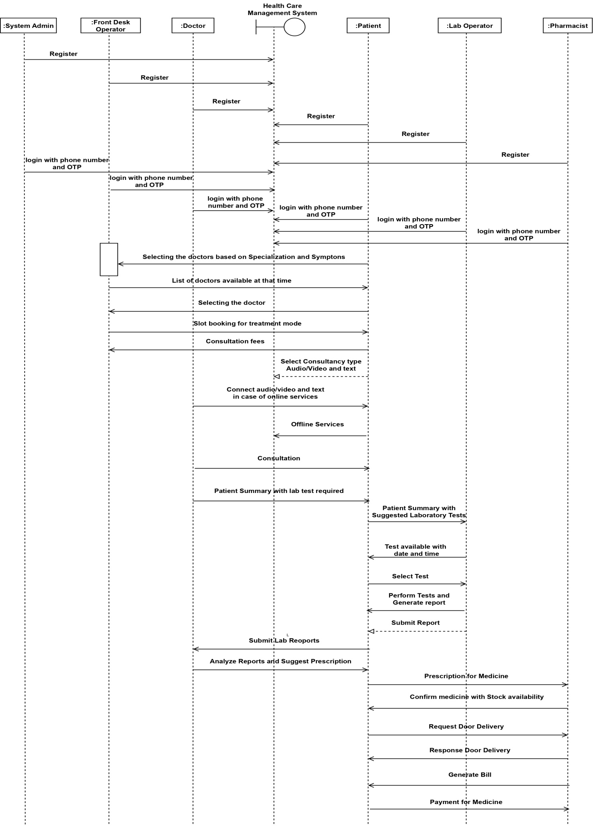

**NOTIFICATIONS:**

In case of doctor's leaves, Emergency_slot_booking, offline quires the front_desk_operator has to get notified

In case of the less stock availability the pharmacist has to able to give notification to the front desk operator so that the front_desk_operator will pass the information to the management

**Reporting:**

The system has to accept the reports in the formats (pdfs,words,image)